Secure Coding Lab-6

# Chekuri.mahesh

18BCN7101 L39+L40



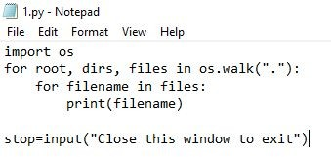

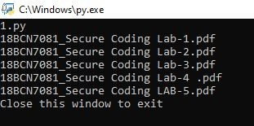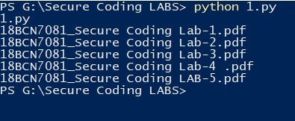

* Write a python script to get all the directory names in the current directory
  1. py - Notepa d

File Edit Format View Help

/npo rt os

dinectony_contents = os.listdir(”. ”) for item in directory_contents:

if os.path.isdir(item): print(item)

stop=input(”Press Enter to exit 18BCN7B81”)

!,fi' C:\\Vindows\ py. ae



$REC*CLE.9IM 189CM7081

ACS Labs

ACS -hoery ASGMs AI LA9S

Cloud CSE2010

eclipse-uor space

F A L L S E N 3 - 1

LAu’ sgns

Pensonai finance Se:une Coding LA9S

S;s:-em Voiume ?nfonma:-ion l.eb Lab

fress Enter zo exit t89CM?081

\Vindows p owershell

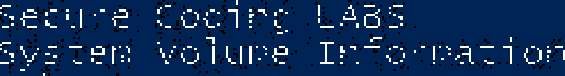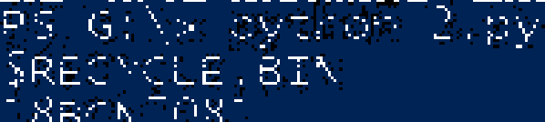

' Write a python script to get all the direct0ry and subdirectory nam»s in the

current direct0r/

* 1. py - Notepa d

File Edit Format View Help

import os

for root, dirs, files in os.walk("."):

for name in dirs :

joint: (as.path . j own (root , name ) )

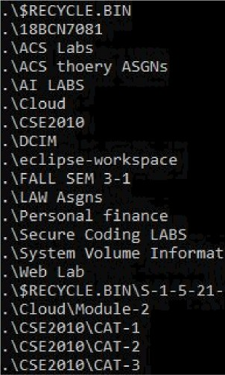stop=Znput(“Press Enter to exit 18BCN7B81") 6' C:\Windows\py.ae

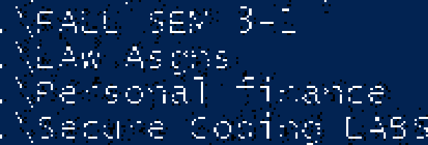

* Write a python script to get all the file name, directory and all the subdirenory ng h£•s (recursively) in the currefit directory

4.py - Notepad

File Edit Form at View Help

import as

for dirs, files in os.walk(“.”):

print(dirs, files)

stop=input("Press Enter to erit 18BCM7B81“)

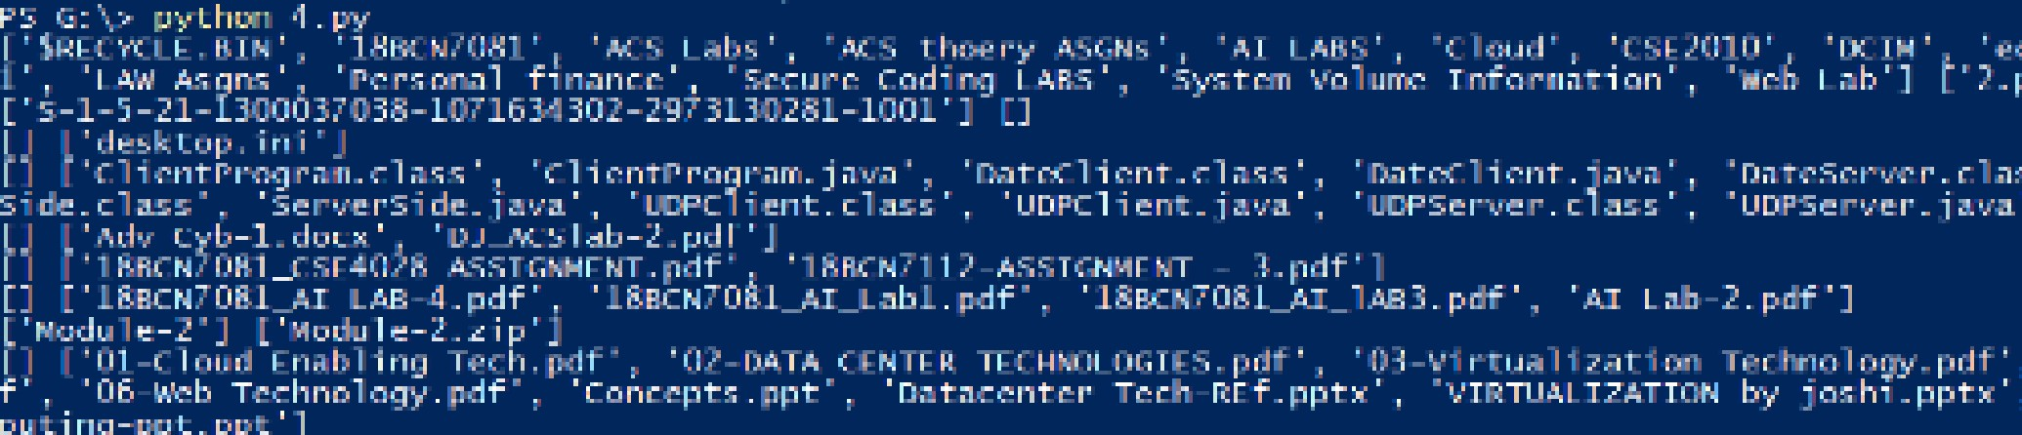

[’$RECYCLE.BIM’, ’18BCN7081’, ’ACS Labs’, ’ACS thoeny ASGMs’, ’AI UBS’, ’Cloud’, ’CSE2010’, ’DCI

’, ’Secune Coding LABS’, ’System VOlume Information’, ’Meb Lab’] [’2.py’, ’3.py’, ’4.py’] [’S-1-5-21-13BBB37038-10716343B2-2973130281-1BB1’] []

[] [’desktop.ini’]

[] [’Cl1entPnognam.class’, ’ClientPnognam.java’, ’DateClient.class’, ’DateClient.java’, ’DateSenv DPElient.class', 'UDPElient.java', 'UDP5erver.class', 'UDP5erver.java']

[] ['cdv Cyb-1.docx', 'DJ_AC5lab-2.pdf']

[] ['18BCM7B81_C5E4B28 A55IGM£tEMT.pdf', ’18BCM7112-A55IGN£tEMT - 3.pdf']

[] ['18BCM7B81_AI LAB-4.pdf', '18BEN7B81_flI_Lab1.pdf', '18BCM7B81_AI_lAB3.pdf', 'AI Lab-2.pdf']

['Module-2'] ['›todule-2.zip']

[] [’01-Cloud Enabling Tech.pdf’, ’02-DATA CEMTER TECHNOLOGIES.pdf’, ’03-Virtualization Technolog epts.ppt’, ’Datacenter Tech-REf.pptx’, ’VIRTUALIZATION by joshi.pptx’, ’Virtualization-and-Cloud-

[] [’CSE2B1B Minten18-19 CAT-1 1.pdf’, ’CSE2B1B M1nten18-19 CAT-1 2.pdf’, ’CSE2B10 tV1nten18-19 CA

[ ] [ ' CS E 2B1B_\'/1nte r 2818 - 19_CAT -2_1. pdf ' , ' CS E 2B18_I'/1nte r‘ 2B18- 19_CAT -2_2 . pdf ' , ' CS E 2818_l'/1nte r 2

* Smite a python scri it to get all the file nan e, d irectory and a I the s i bdi rec:a ry narr es (r«cri rsively) in the current d rivo and write it to a text

/I IR.

fi.py - Notepa d

File Edit Format View Help

ixpo rt os

f_output=open(”O5.txt”, ”a”)

for root, dirs, files in os.walk(”.”):

for dins in dins:

f_output.write('\n' + dirs) f_output.write(’\n\n’)

for files in files:

f_output.write('\n' + files ) stop=input(”Press Enten to exit 18BCM7081”)

\Vindows p owershell

PS" G :” Python ” 5 . py

Pres s E nt:er I:o ext I: 18BCN7 081

PS G : \>

”| 0 fi.txt - Notepad

File Edit Form at View Help

$RECYC L E . BIN 18BCLJ7081

ACS Labs

ACS thoe ry AS GU s

AI LABS

Cloud CS£2818 DCIM

eclipse-workspace

FALL SEN 3 -1

LAN Asgns

Personal finances

Secure Coding LABS

System Volume Information Web Lab

2. py

4.py

5 • BY

05. txt



import subprocess

process = subprocess.Popen(["powershell","New-Item 18BCN7081_0.txt,18BCN7081_1.txt,18BCN7081_2.txt,18BCN7081_3.txt"

],stdout=subprocess.PIPE) result=process.communicate()[0] print(result)

stop=input("Press Enter to exit 18BCN7081")

